ST. XAVIER’S COLLEGE

**Maitighar, Kathmandu**



**Computer Graphics**

**Lab Assignment #7**

**SUBMITTED BY:**

**Siddhant Rimal**

**013BSCCSIT039**

**SUBMITTED TO**

|  |  |
| --- | --- |
| **Er. Anil Sah**  **( Lecturer )** |  |
| **Department of Computer Science** | |

Submission Date: 1st September 2015

**OBJECTIVE 4.1: TO TRANSLATE AN IMAGE**

|  |
| --- |
| **SOURCE CODE:** |
| //--------------------------------------------------------------------------- |
| #include <vcl\vcl.h> |
| #pragma hdrstop |
| #include "Trans.h" |
| #include <math.h> |
| //--------------------------------------------------------------------------- |
| #pragma resource "*.dfm" |
| TForm2 *Form2; |
| int x,y,i,j,Tx,Ty,theta,shx,shy,ix,jy; |
| float t; |
| //--------------------------------------------------------------------------- |
| __fastcall TForm2::TForm2(TComponent* Owner) |
| : TForm(Owner) |
| { |
| } |
| //--------------------------------------------------------------------------- |
| void __fastcall TForm2::TranslateClick(TObject *Sender) |
| { |
| x=Image1->Height; |
| y=Image1->Width; |
| Tx=StrToInt(TX->Text); |
| Ty=StrToInt(TY->Text); |
| for(i=0;i<=x;i++){ |
| for(j=0;j<=y;j++){ |
| Image2->Canvas->Pixels[i+Tx][j+Ty]=Image1->Canvas->Pixels[i][j]; |
| } |
| } |
| } |
| //--------------------------------------------------------------------------- |
| void __fastcall TForm2::RotateClick(TObject *Sender) |
| { |
| x=Image1->Height; |
| y=Image1->Width; |
| theta=StrToInt(Theta->Text); |
| for(i=0;i<x;i++){ |
| for(j=0;j<y;j++){ |
| Image2->Canvas->Pixels[300+i*cos(theta)-j*sin(theta)][200+i*sin(theta)+j*cos(theta)]=Image1->Canvas->Pixels[i][j]; |
| } |
| } |
| } |
| //--------------------------------------------------------------------------- |
| void __fastcall TForm2::Button1Click(TObject *Sender) |
| { |
| x=Image1->Height; |
| y=Image1->Width; |
| t=StrToFloat(T->Text); |
| for(i=0;i<=x;i++){ |
| for(j=0;j<=y;j++){ |
| Image2->Canvas->Pixels[i*t][j*t]=Image1->Canvas->Pixels[i][j]; |
| } |
| } |
| } |
| //--------------------------------------------------------------------------- |
| void __fastcall TForm2::ShearXClick(TObject *Sender) |
| { |
| x=Image1->Height; |
| y=Image1->Width; |
| shx=StrToFloat(SHX->Text); |
| for(i=0;i<=x;i++){ |
| for(j=0;j<=y;j++){ |
| Image2->Canvas->Pixels[i+shx*j][j]=Image1->Canvas->Pixels[i][j]; |
| } |
| } |
|  |
| } |
| //--------------------------------------------------------------------------- |
| void __fastcall TForm2::ShearYClick(TObject *Sender) |
| { |
| x=Image1->Height; |
| y=Image1->Width; |
| shy=StrToFloat(SHY->Text); |
| for(i=0;i<=x;i++){ |
| for(j=0;j<=y;j++){ |
| Image2->Canvas->Pixels[i][shy*i+j]=Image1->Canvas->Pixels[i][j]; |
| } |
| } |
| } |
| //--------------------------------------------------------------------------- |

**OUTPUT:**

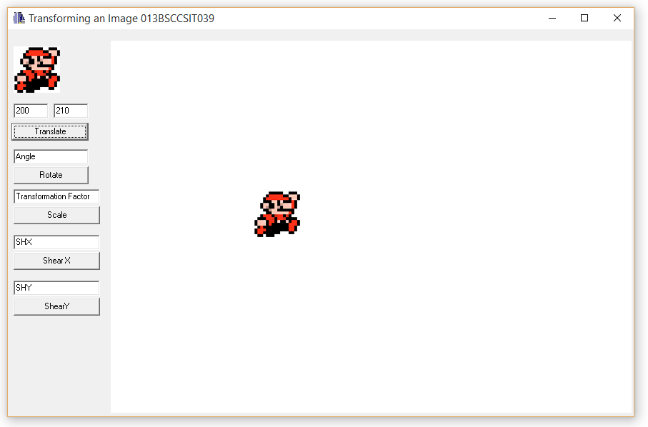

Fig: Translating an image of mario

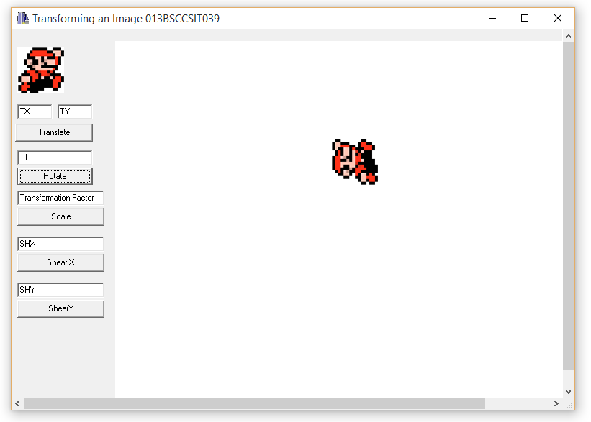

Fig: Rotating an image of mario

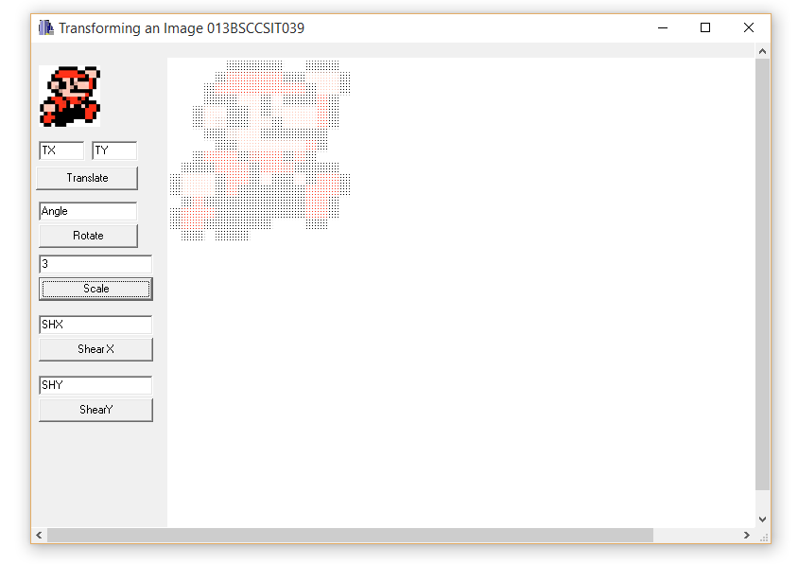

Fig: Scaling an image of Mario by a factor of 3

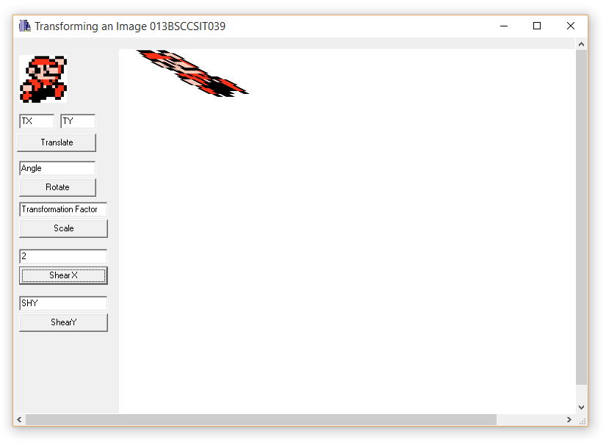

Fig: Shearing an image of Mario in the X direction at Shx=2

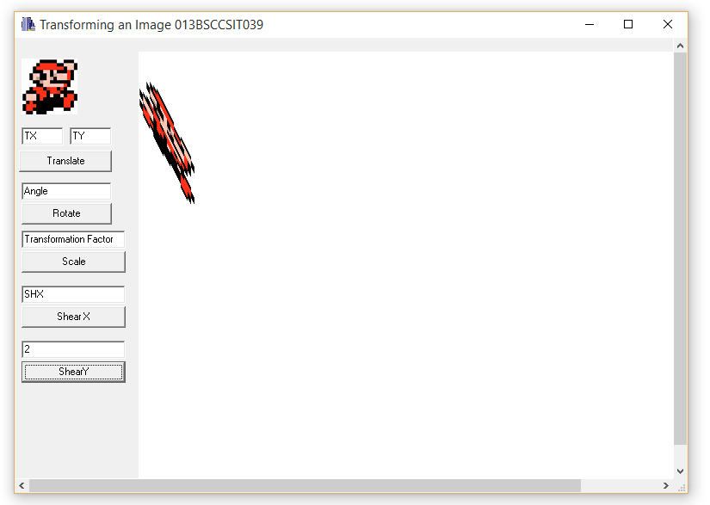

Fig: Shearing an image of Mario in the Y direction at Shy=2

**CONCLUSION:**

The program could transform a sample image in various ways. It is possible to scale, translate, rotate and shear an image with simple set of codes that modify the whole image viewport on which the image is located.